
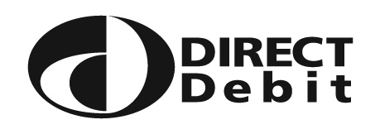
NORTHERN OIL
Co. Ltd. Nottingham

Please complete and return to:
Credit Control
Wollaton Road
Nottingham
NG8 1HJ

Instruction to your bank
Bank or Building Society
to pay by Direct Debit

Name(s) of Account Holder(s)
Service User Number

6 | 8 | 1 | 4 | 8 | 2

Bank/Building Society account number

Reference

Branch Sort Code

Name and full postal address of your
Bank/Building Society
Instruction to your Bank or Building Society Please pay Northern Oil Company Limited Direct Debits from the account detailed in this instruction subject to the safeguards assured by the Direct Debit Guarantee. I understand that this instruction may remain with Northern Oil Company Limited and, if so, details will be passed electronically to my Bank/Building Society.

Signature(s)

Date

Banks and building societies may not accept Direct Debit Instructions for some types of account

The Direct Debit Guarantee

This Guarantee is offered by all Banks and Building Societies that take part in the Direct Debit Scheme. The efficiency and security of the Scheme is monitored and protected by your own Bank or Building Society.

If there are any changes to the amount, date or frequency of your Direct Debit, Northern Oil Company Limited will notify you 10 working days in advance of your account being debited or as otherwise agreed.

If an error is made in the payment of your Direct Debit, by Northern Oil Company Limited or your Bank or Building Society, you are entitled to a full and immediate refund of the amount paid from your bank or building society – if you receive a refund, you are not entitled to, you must pay it back when Northern Oil Company Limited asks you to.

You can cancel a Direct Debit at any time by simply contacting your Bank or Building Society. Written confirmation may be required. Please also notify us.

